Civil war in [Rwanda]

UNSC Resolution: | 1161
Date of adoption: | 9-April-1998
Operative paragraph: | 4
Demand number: | 1161.0411

[Philippe Rieder]

Wording of demand

Ensure that their territory is not used as a base for armed groups to launch incursions or attacks against any other State in violation of principles of international law and the Charter of the United Nations

List of addressees of the demand

Government of Rwanda, States in the Great Lakes region

Short-term compliance

Description of the addressee(s)’ conduct

“By the Spring of 1998, (…) the anti-Rwandan feelings which existed before the war grew worse. One of the reasons for this steady deterioration was the attitude of a number of Rwandan and Congolese Tutsi, civilians and military alike, who behaved as if they were operating in occupied territory. Local populations were harassed, insulted and humiliated; the 'liberators' seized household appliances, communication equipment, cars, cattle and houses; traditional chiefs were demoted and ridiculed, some even killed; the best positions in the new administration and the army went to the 'new rulers'; thousands of civilians were killed in anti-insurgency operations by the RPA and Banyarwanda elements of the FAC. Already by the end of 1996, a number of organizations and movements started to emerge whose stated objective was to fight 'Tutsi hegemonism' and which used violent anti-Tutsi language.” (Filip Reyntjens, Briefing: The Second Congo War: More than a Remake, in: African Affairs (1999), 98, p. 243f)

“41. In 1997 a coalition of rebel movements under the leadership of the Alliance of Democratic Forces for the Liberation of Congo-Zaire (ADFL), with support from neighbouring countries, overthrew the government of President Mobutu and took power. Internal discord within the alliance and disagreements with some neighbouring countries over the activities of foreign armed groups on DRC territory led to a resumption of the conflict that saw the involvement of five Congolese belligerents; Government, four major rebel groups: Congolese Rally for Democracy (RCD), Movement for the Liberation of Congo (MLC), Kisangani Liberation Movement (RCD-K/ML) and Congolese Rally for Democracy-National (RCD-N) as well as six foreign countries Angola, Chad, Namibia, Rwanda, Uganda and Zimbabwe, in support of either the government or the rebels.” (United Nations Special Advisor for Africa and Government of the Republic of Sierra Leone: Disarmament, Demobilization, Reintegration (DDR) and Stability
in Africa, Conference Report, Freetown and New York 2005, 21-23 June 2005, p. 16)

“A major part of these [Kabila’s ADFL] armed forces originated in Kivu, the eastern part of the country, many even from the neighbouring states, Rwanda and Uganda. In a secondary phase soldiers from Katanga, who had over a long time lived and fought in Angola, joined the ranks. And without any doubt Kabila's eastern neighbours, Rwanda and Uganda, were giving active support, so as secure their own borders and to forestall hostilities on the part of armed rebel groups, which operated frequently from
Zairean territory and were often financed by that side.” (Henry C. Hoeben: Human Rights in the DR Congo: 1997 until the present day, Internationales Katholisches Missionswerk e.V., Fachstelle Menschenrechte, Aachen 2001, p. 9)

“In July 1998, Kabila therefore announced that the military co-operation agreement between Congo and Rwanda had served its purposes and was to end. Rwandan troops were to return to their side of the border as swiftly as possible. They did so, only to re-emerge almost immediately, this time as an enemy army. The Second Congo War had begun. (…)
Kabila's break with his former allies had also consequences for other population groups in Congo, particularly the Banyarwanda and the Banyamulenge. Various Congolese political groups, like FLC, MLC, RCD etc., had used Kabila's victory over Kinshasa as a pretext to put forward their political claims. They had readily accepted the political and military support of either Rwanda or Uganda depending mainly on the specific interest of the group's leader. The Banyamulenge in particular felt to have been manipulated by the authorities of Kigali.” (Henry C. Hoeben: Human Rights in the DR Congo: 1997 until the present day, Internationales Katholisches Missionswerk e.V., Fachstelle Menschenrechte, Aachen 2001, p. 9)

“The in-coming Rwandan army had successfully camouflaged their invasion into Eastern Kivu under the name of a Congolese Rebel movement, called RCD, which later split into pro-Rwanda and pro-Uganda factions. But there were also numerous and widespread unconfirmed reports that armed bands of Rwandan Hutus posing as Interahamwe fighters committed abuses. The Rwandan army allegedly recruited these groups having them operate as an instrument of terror against civilians. The Rwandan authorities themselves reportedly coordinated these attacks on civilian and church targets and then blamed the attacks on the Interahamwe.” (Henry C. Hoeben: Human Rights in the DR Congo: 1997 until the present day, Internationales Katholisches Missionswerk e.V., Fachstelle Menschenrechte, Aachen 2001, p. 21)

“Rebel movements from Uganda (ADF), Rwanda (former government army FAR and
interahamwe militia) and Burundi (CNDD-FDD) used Congolese territory as bases for
assault and retreat; to some extent they benefited from (at least passive) complicity,
and at any rate territorial control of the collapsed state was nominal at most.”
(Marc Cogen & Filip Reyntjens, The Great Lakes, Kivu and the Search for Peace; Faculty of Law, University of Gent, 19 August 1999, p. 1f)

“The anti-Tutsism is reinforced by the fear of the extension into the Kivu of the Rwandan political-military space. After the presentation of maps of the “Greater Rwanda” by Rwandan officials at the beginning of the 1996-7 war, this fear is further compounded by the way in which the RPA ignores international boundaries (in the region, the Rwandan army is nicknamed “soldiers without borders”) and by the mooting in circles considered close to Kigali of the concept of a “transborder citizenship”.” (Marc Cogen & Filip Reyntjens, The Great Lakes, Kivu and the Search for Peace; Faculty of Law, University of Gent, 19 August 1999, p. 3)

“However, this is where the new war proved not to be a simple repeat of the 1996-7 rebellion. While the latter enjoyed near unanimous support both within and outside the country, the alliance -aiming as it was at the overthrow of Mobutu- was nevertheless, as said before, temporal and therefore fragile. This frailty showed immediately in August 1998, when coalitions started to shift almost overnight in a spectacular fashion: again reasoning in the logic of “the enemy of my enemy is my friend”, yesterday’s allies became adversaries. On the Western front, Kabila was saved by the intervention of an Angolan expeditionary force, sent in support as a result of a decision taken on 19 August in Harare when Zimbabwe, Namibia and Angola responded positively to a request for assistance in the framework of the SADC.
Realignments went even further. Thus the mai-mai in the East, who had been fighting Kabila even before he came to power, now aligned with him in the context of the “anti-Tutsi” coalition. Within the same logic, an even more spectacular shift brought the ex-FAR and interahamwe militia into Kabila’s camp, although less than a year earlier, the Rwandan Hutu had suffered massive loss of life during and after the previous rebellion at the hands of Kabila and his erstwhile allies. FAR were brought in from neighbouring countries, rearmed, retrained, and massively deployed on both the Northern and the Southern fronts.” (Marc Cogen & Filip Reyntjens, The Great Lakes, Kivu and the Search for Peace; Faculty of Law, University of Gent, 19 August 1999, p. 3f)

“The complexity of the situation is further compounded by the sheer
number of actors: in the Great Lakes region alone, four government armies, two
former government armies and over a dozen rebel groups and ethnic militia are
presently engaged in violent confrontation.” (Marc Cogen & Filip Reyntjens, The Great Lakes, Kivu and the Search for Peace; Faculty of Law, University of Gent, 19 August 1999, p. 5)

“In 1998, a rebellion against the Kabila Government started in Kivu, and within weeks the rebels had seized large areas of the country. Angola, Chad, Kenya, Namibia and Zimbabwe promised and provided President Kabila with military support. Despite the recapture of several towns and halting of a rebel advance on Kinshasa, the rebels maintained their grip on the eastern regions. The rebel movement, the Congolese Rally for Democracy (RCD), was supported by Rwanda and Uganda. The Security Council called for a ceasefire and the withdrawal of foreign forces, and urged States not to interfere in the country's internal affairs. Uganda signed a peace agreement with the Kabila Government in April 1999. In May, the RCD split into two factions.
Efforts by the Secretary-General, the Organization of African Unity (OAU) and Southern African Development Community (SADC) led in July 1999 to the Lusaka Ceasefire Agreement. Signed by the Democratic Republic of the Congo, along with Angola, Namibia, Rwanda, Uganda and Zimbabwe, it provided for an end of hostilities and for the holding of an inter-Congolese dialogue.” (UNSC Press Release (SC/7132), 30 August 2001, on: http://www.un.org/News/Press/docs/2001/SC7132.doc.htm, (21 September 2009))

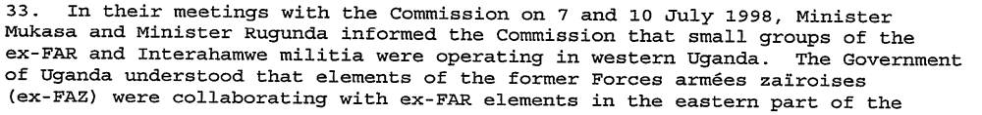
(Interim Report of the International Commission of Inquiry, in: Annex of Letter dated 18 August 1998 from the Secretary-General to the President of the Security Council, (S/1998/777), 19 August 1998, p. 8)

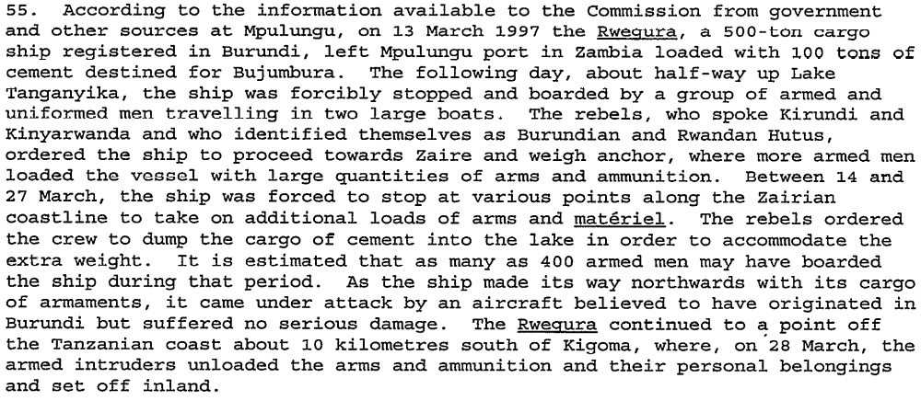
(Interim Report of the International Commission of Inquiry, in: Annex of Letter dated 18 August 1998 from the Secretary-General to the President of the Security Council, (S/1998/777), 19 August 1998, p. 12)

“Following the 1994 massacres in Rwanda and the establishment of a new Government there, some 1.2 million Rwandese Hutus -- including some who had taken part in the genocide -- fled to Kivu province in eastern Zaire, an area partly inhabited by ethnic Tutsis. There, a rebellion started in 1996, pitting Zairean Tutsis, led by Laurent Désiré Kabila, against the pro-Hutu army of President Mobutu Sese Seko. Kabila's Alliance of Democratic Forces for the Liberation of Zaire/Congo (ADFL), aided by Rwanda and Uganda, took Kinshasa, the capital, in 1997, and established the Democratic Republic of the Congo. The civil war resulted in more than 450,000 refugees and internally displaced people.” (UNSC Press Release (SC/7132), 30 August 2001, on: http://www.un.org/News/Press/docs/2001/SC7132.doc.htm, (21 September 2009))

Assessment

Short-term compliance
X No or marginal compliance (1) | Medium low compliance (2) | Medium high compliance (3) | Full or almost full compliance (4)

Considerations underlying the assessment

Alliances shifted by the end of 1997 because Kabila wanted to diminish Rwandan and Ugandan influence on his government and force them out of the country. By allying himself with his old enemies, the Ex-FAR and the Mai-Mai who had the same anti-Tutsi aims, he challenged the Governments of Rwanda and Uganda directly, who in turn invaded directly and supported the Banyamulenge-revolution against Kabila.

Medium-term compliance

Description of the addressee(s)’ conduct

“The Security Council, inter alia, called for a peaceful solution to the conflict in the Democratic Republic of the Congo, including an immediate ceasefire, the
orderly withdrawal of all foreign forces, arrangements for security along the international borders of the Democratic Republic of the Congo, the reestablishment of the authority of the Government of the Democratic Republic of the Congo over the whole territory of the country;” (Presidential statement, (S/PRST/1998/36), 11 December 1998)

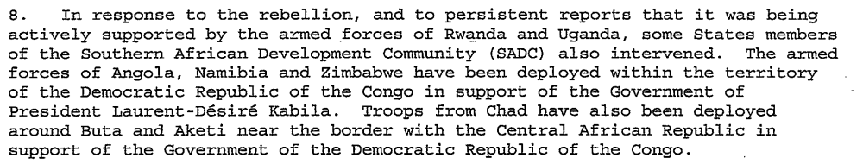
(Final Report of the International Commission of Inquiry, in : Annex of Letter dated 18 November 1998 from the Secretary-General to the President of the Security Council, (S/1998/1096), 18 November 1998, p. 3)

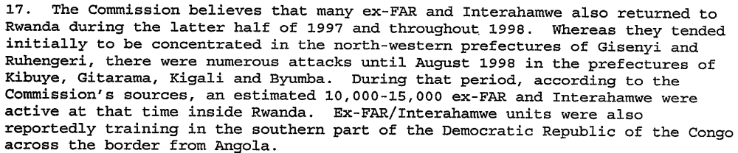
(Final Report of the International Commission of Inquiry, in: Annex of Letter dated 18 November 1998 from the Secretary-General to the President of the Security Council, (S/1998/1096), 18 November 1998, p. 5)

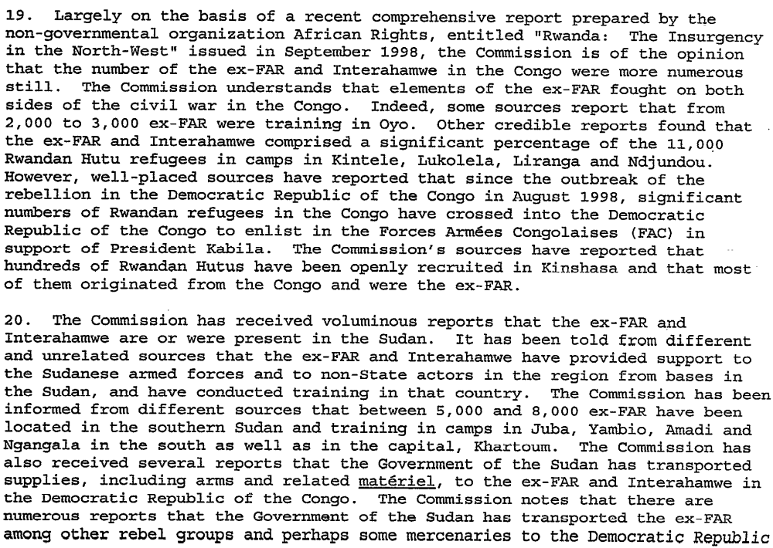
(Final Report of the International Commission of Inquiry, in: Annex of Letter dated 18 November 1998 from the Secretary-General to the President of the Security Council, (S/1998/1096), 18 November 1998, p. 5f)

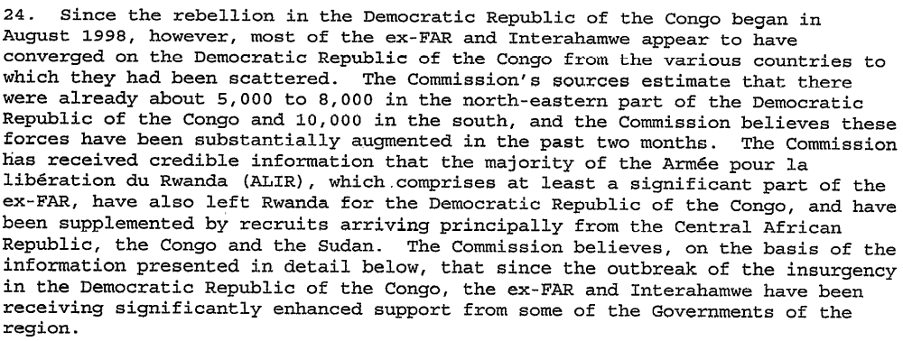
Final Report of the International Commission of Inquiry, in: Annex of Letter dated 18 November 1998 from the Secretary-General to the President of the Security Council, (S/1998/1096), 18 November 1998, p. 6)

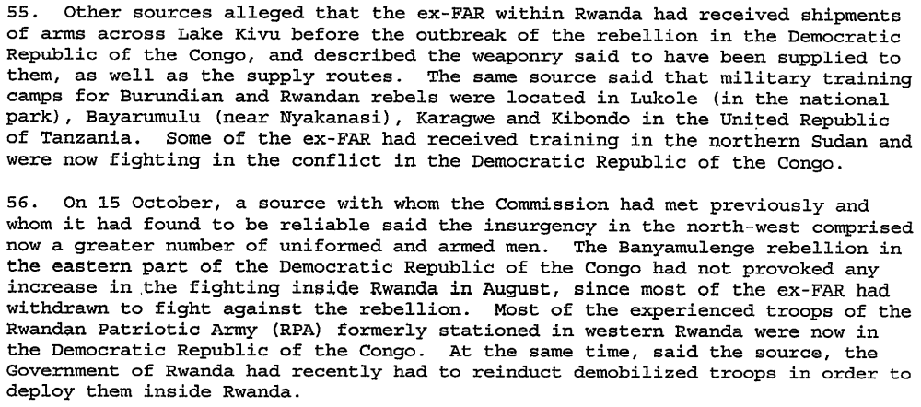
Final Report of the International Commission of Inquiry, in: Annex of Letter dated 18 November 1998 from the Secretary-General to the President of the Security Council, (S/1998/1096), 18 November 1998, p. 12)

“The Minister of Human Rights of the Democratic Republic of the Congo told the Security Council today that the stubborn presence of Rwanda and Uganda in his country had been the sole obstacle to peace, as the Council held an open meeting on the conflict in that country.
The Minister, one of 31 speakers to address the Council today, said those two countries were citing border insecurity as a pretext for their aggression, while the international community had made only "timid declarations" against violations of his country's territorial integrity. He said the Council should consider the deployment of peacekeepers to secure the shared 2,000-kilometre borders with its eastern neighbours -- Burundi, Rwanda and Uganda. (…)
The Rwandan representative told the Council that his Government respected the territorial integrity and sovereignty of all nations. The Democratic Republic of the Congo, however, should dismantle the dozen non- State armies that were being used to conduct aggression against the territorial integrity of its neighbours. His country was resolved to join others in a coalition against the recurrence of genocide and terrorism in the Great Lakes region and elsewhere. Unfortunately, like the prior leadership of then Zaire, the Democratic Republic leadership embraced the evil forces of genocide, which had inevitably led to the current crisis.” (Security Council Press Release, (SC/6654), 3987th Meeting, 19 March 1999)

“The Security Council, inter alia, deplored the continuing fighting and the
presence of forces of foreign States in the Democratic Republic of the Congo
in a manner inconsistent with the principles of the Charter; called upon those
States to bring to an end the presence of those uninvited forces and to take
immediate steps to that end; condemned all massacres carried out on the
territory of the Democratic Republic of the Congo;” (UNSC Resolution 1234 (1999), (S/RES/1999/1234), 9 April 1999)

“15. The Democratic Republic of the Congo is bedevilled by various armed conflicts, some international, others internal and yet other internal conflicts that have been internationalized (see E/CN.4/2000/42, para. 20). Participants in these conflicts include at least eight national armies1 and 21 irregular armed groups. All of these forces are operating entirely in the territory of the Democratic Republic of the Congo, which has seen its population decimated and its wealth extracted by occupying and rebel forces.”, Note by the Secretary-General to the Situation of human rights in the Democratic Republic of the Congo, (A/55/403), 20 September 2000, p. 4)

“By resolution 1258 (1999), the Security Council, inter alia, welcomed the signing of the Ceasefire Agreement on the conflict in the Democratic Republic of the Congo by the States concerned in Lusaka on 10 July 1999 (S/1999/815), which represented a viable basis for a resolution of the conflict; also welcomed the signing of the Ceasefire Agreement on 1 August 1999 by the Movement for the Liberation of the Congo; expressed deep concern that the Congolese Rally for Democracy had not signed the Agreement and called upon the latter to sign the Agreement without delay in order to bring about national reconciliation and lasting peace in the Democratic Republic of the Congo; called upon all parties to the conflict, in particular the rebel movements, to cease hostilities, to implement fully and without delay the provisions of the Ceasefire Agreement, …” (UN Report of the Security Council, 16 June 1999-15 June 2000, UN New York 2000, p. 33)

“In the Democratic Republic of the Congo the negotiations intensified, culminating in the signing of the Ceasefire Agreement by the rebel movements, the Movement for the Liberation of the Congo (MLC) and the Congolese Rally for Democracy (RCD).” (Events in August 1999, in: UN Report of the Security Council, 16 June 1999-15 June 2000, UN New York 2000, p. 456)

“The members of the Council expressed their appreciation to the Department of Peacekeeping Operations for the timely action undertaken in preparing for the deployment of military liaison officers as authorized by resolution 1258 (1999). They emphasized the importance of preserving and implementing the Ceasefire Agreement and called upon the leaders of RCD to sign the Agreement. Some members undertook to continue efforts to exert the necessary influence to get RCD to sign the Agreement.” (Events in August 1999, in: UN Report of the Security Council, 16 June 1999-15 June 2000, UN New York 2000, p. 459)

“Members of the Council were briefed on the situation in the Democratic Republic of the Congo. They welcomed the signing of the Lusaka Ceasefire Agreement by the Rassemblement congolais pour la démocratie (RCD), which took place in Lusaka on 31
August last; and urged all parties to abide strictly by the Ceasefire Agreement and to refrain from any action putting it at risk.” (Events in August 1999, in: UN Report of the Security Council, 16 June 1999-15 June 2000, UN New York 2000, p. 475)

“The Great Lakes region of Africa has become the place of the continent’s first Great
War. Fighting is concentrated in eastern Congo and has drawn in a host of regional powers, dragging sub-Sahara Africa into a morass of seemingly endless interlinked conflicts. The armed conflict in eastern Congo is one of the most dangerous conflicts in the world today, with at least eight foreign countries directly involved as well as a plethora of non-state actors.” (Marc Cogen & Filip Reyntjens, The Great Lakes, Kivu and the Search for Peace; Faculty of Law, University of Gent, 19 August 1999, p. 15)

“109. None of the parties to the nine conflicts, whether internal, internationalized internal or international, is fully respecting the Lusaka Ceasefire Agreement, although there has been no significant change in their positions. The Congolese consider the Rwandan, Ugandan and Burundian armies to be “aggressors” rather than as providing support to the rebels. While the activities of the Interahamwe and Mai-Mai are the primary cause of the violence, it is the armies of Rwanda, Uganda, Burundi and Rassemblement congolais pour la démocratie (RCD) which are causing the greatest damage and which have once again committed terrible massacres of the civilian population. In addition, Rwanda and Uganda have expanded their own conflicts into Congolese territory, causing death and destruction on neighbouring soil.”
(Note by the Secretary General to the situation of Human Rights in the Democratic Republic of Congo, (AA/55/403), 20 September 2000, p. 13f)

“Uganda's Minister of State for Foreign Affairs and Regional Cooperation questioned the principles forming the basis of the investigation and the quality of the evidence presented. As the report implicated top Ugandan military officers and civilians in illegal exploitation of Congolese resources, the Ugandan Government had decided to establish an independent judicial commission to investigate the allegations. However, he questioned the quality and credibility of the document.
The Special Envoy of the President of Rwanda said that as his country's security concerns could not be minimized by any other consideration, only the Lusaka Agreement could provide equitable solutions to the problems facing all the parties to the conflict.
Burundi’s Minister of Finance, said his country's role was dictated by the rebel presence in the border region and by the need to keep open trade corridors to the United Republic of Tanzania. Burundi had no designs whatsoever on the territory of the Democratic Republic of the Congo. Burundi was ready to pursue dialogue with all parties to secure the borders and end all the tensions tearing the region apart.” (Security Council Press Release (SC/7057), 30 May 2001, http://www.un.org/News/Press/docs/2001/sc7057.doc.htm (25 September 2009))

“The [Congo War’s] second phase was one of systematic and systemic exploitation, requiring planning and organization, the report states. That exploitation flourished because of the structures developed during the conquest of power of the Alliance of Democratic Forces for the Liberation of Congo-Zaire. It was carried out in violation of the sovereignty of the DRC, national legislation and sometimes international law, and led to illicit activities. Key individual actors, on the one hand, including top army commanders and businessmen, and government structures, on the other, have been the engines of that systematic and systemic exploitation.
According to the report, illegal exploitation of resources by Burundi, Rwanda and Uganda took different forms, including confiscation, extraction, forced monopoly and price-fixing. The first two forms reached proportions that made the war in the DRC a very lucrative business. There are strong indications that, even if security and political reasons were the professed motivation to move into the eastern DRC, some top army officials clearly had economic and financial objectives.” (Security Council Press Release (SC/7057), 30 May 2001, http://www.un.org/News/Press/docs/2001/sc7057.doc.htm (25September 2009))

“CAMERON R.HUME (United States) said the implementation of the Lusaka Agreement had been a roller coaster. While the ceasefire was holding, for example, the forces of principal belligerents still remained in place. The humanitarian and human rights situations had also not improved and that was an area of great concern. Negative forces continued to receive arms and there was still a propensity to violence in some areas. Some forces also seemed to be receiving support from elements in the Government of the Democratic Republic of the Congo, while Kisangani had yet to de demilitarized. In addition, a relevant and credible political plan for the disengagement of forces was yet to be presented.” ((Security Council Press Release (SC/7132), 30 August 2001, http://www.un.org/News/Press/docs/2001/SC7132.doc.htm (23 September 2009))

Assessment

Medium-term compliance
X No or marginal compliance (1) | Medium low compliance (2) | Medium high compliance (3) | Full or almost full compliance (4)

Considerations underlying the assessment

The Congo conflict had a strong economic component. Rwanda’s and Uganda’s armies did not want to withdraw, because they were able to profit from the exploitation of natural resources in areas they occupied. The natural wealth and economic interests have also been reasons for Namibia, Zimbabwe, Angola and Chad to join the conlict on the Government’s side.
The war went on until 2003 and rebel movements are active in the DRC even today.

Depth of Demand

Assessment

Level of depth of demand
Low depth of demand (1) | Medium depth of demand (2) | X High depth of demand (3)

Considerations underlying the assessment

Most of the armies involved in the Second Congo war used armed groups as proxies to ensure their security and do the “dirty work”. Rwanda supported the RCD, Uganda the MLC and the Kabila government gave its support to the Ex-FAR/Interahamwe/ALiR and the Mai-Mai.

Level of confidence about coding decisions

Level of confidence about coding decision
Extremely high | X High | Moderate

Comments to IPI (if any)

